As you can discern from the foray reports, we have been increasingly tackling the LBJ's or 'Little Brown Jobs' of the fungal kingdom. Penny found the rare Conocybe percincta at Pulpit Hill in November 2007 (fig.27). It is new to the County. On the same visit, Galerina praticola and Coprinopsis pseudonivea were also found.
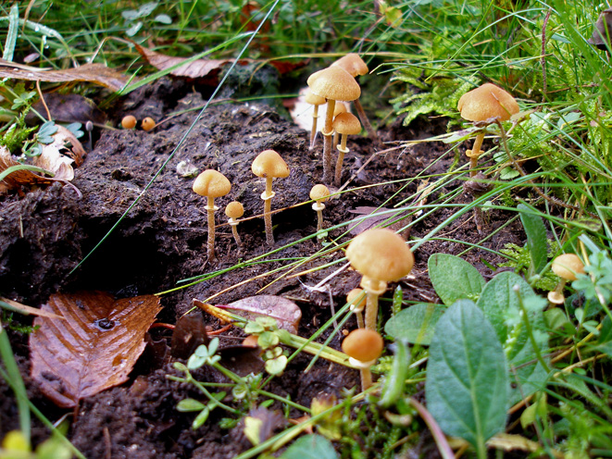

fig.27 Conocybe percincta on cow dung Pulpit Hill 2 Nov 2007 (PC)
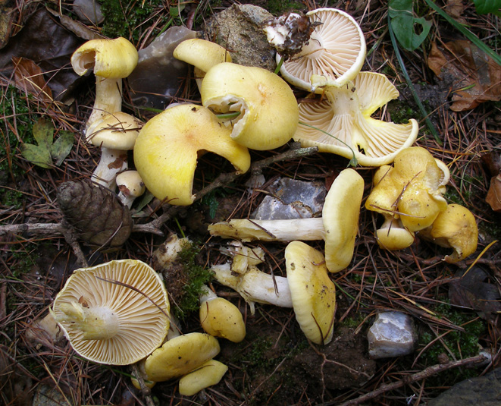

A rather fine species that grows with Larch and fruits late in the season is Hygrophorus lucorum (Larch Woodwax, fig.28) found by Penny this year at Penn Wood and Watlington Hill.

fig.28 Hygrophorus lucorum Watlington Hill 24 Oct 2007 (PC)
Another beautiful picture that I wanted to share with you is one that Penny took of Oudemansiella mucida (Porcelain Fungus, fig.29) at Hodgemoor in October.
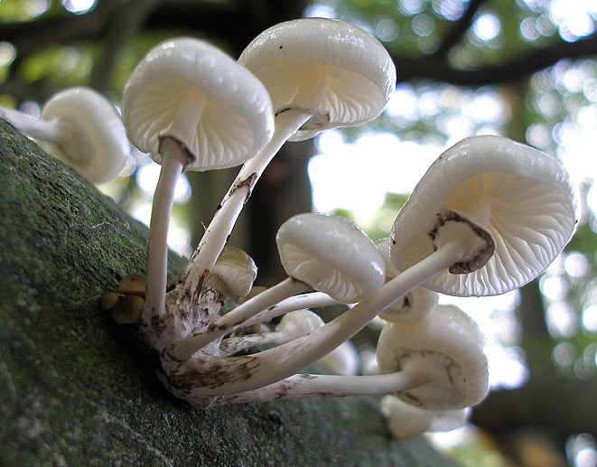

fig.29 Oudemansiella mucida Hodgemoor Woods 10 Oct 2007 (PC)

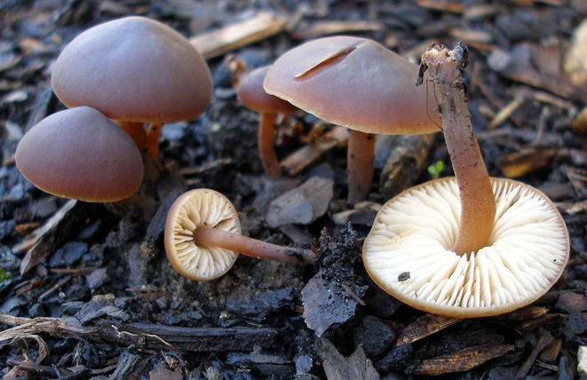
Back at home in November, Penny found some fine material of Macrocystidia cucumis (called Cucumber Cap because of its smell; fig.30 shows the fruit bodies growing in wood chip and also shows a microscopic view of the cystidia that give the fungus its latin name).

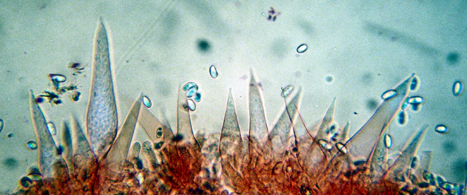

fig.30 Macrocystidia cucumis
Willow Lane Amersham
23 Nov 2007 (PC)

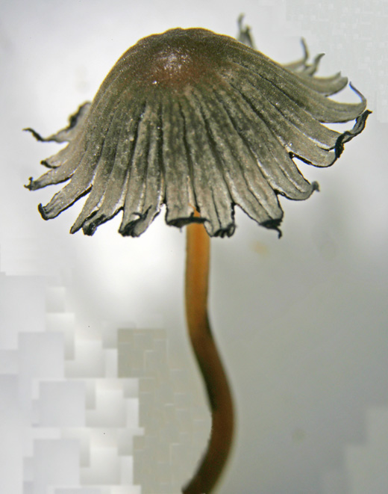
Finally, I couldn't resist including the Coprinellus stellatus (fig.31) that popped up on some Whitchurch horse manure in July demonstrating why it had been given that latin name. Other species have caps that split in a similar way but C. stellatus does it rather well. As it happens, the epithet 'stellatus' has been dropped by some in favour of 'brevisetulosus', but I think it would be a pity to lose it.
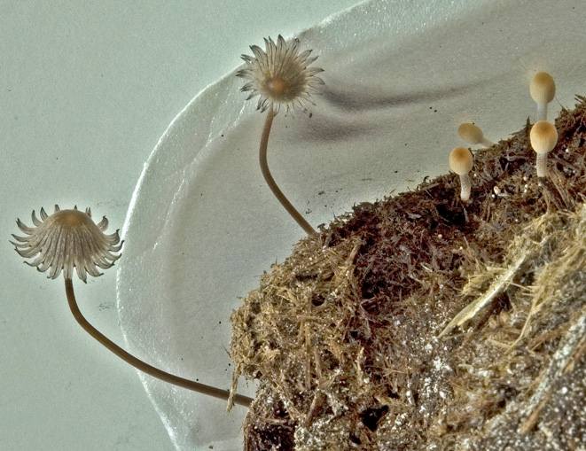

fig.31 Coprinellus stellatus
on horse dung Whitchurch
22 Jul 2008. The cap is
around 12 mm across(DJS)

ANYONE FOR A BIT OF SLIME?

No-one with an interest in fungi needs reminding of the baffling diversity of this kingdom of natural history: the more one discovers about it the more amazed one becomes. A few years back, after attending a BMS weekend workshop with Bruce Ing, I got bitten by a very individual group: the mysterious and often very beautiful Myxomycetes, commonly known as Slime Moulds. Certainly their English name does them no favours, however, and in fact probably puts many people off; this is a shame and partly why I’d like to share with you if I can a little about how they work and how to enjoy them, even if you don’t want to get into identifying them.

Firstly, what is a slime mould? Well, you might recall - if you’ll admit to being old enough! – the radio programme “Twenty Questions” in which the initial question asked by the panellists in their quest to discover the identity of an unknown object was “Animal, vegetable or mineral?” Not so easy in the case of myxos, as they are often called, because they just don’t sit comfortably within any kingdom - not even fungi - although they are studied and recorded by mycologists, who often affectionately refer to them as “honorary” fungi. When the first species was officially named and described back in the 1700s it was thought to fit somewhere near the puffball family (Lycoperdon) being similarly shaped and full of spores when mature,
albeit less than 2 cms across and bright orange. You may recognise from this the very common Lycogala (more on this below). However, during the 1800s it was realised that slime moulds were in fact distinct from fungi because they lack mycelium (the rootlike system present in fungi) but have plasmodium (the soft mobile slimy bit) as an important stage of their development. The name Myxo (= slime) mycete (= fungus) has remained, however, although at one stage it was even thought they could be part of the animal kingdom - the plasmodium actually “moves” across its substrate whilst taking up nutrients before settling down to mature into something much more reminiscent of the fungal kingdom. Now happily residing in kingdom Protozoa, these strange and fascinating organisms are still far from being fully understood.

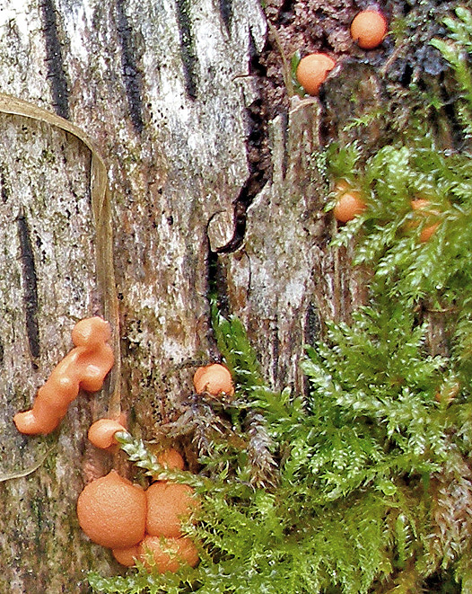
Lycogala terrestre (fig.32, left) with its conspicuous peachy orange blobs is probably the best known and most frequently recorded myxo. Its earlier plasmodial stage of reddish jelly-like slimy patches must of course be just as common, but may often go unnoticed in the field. The mature buff-coloured fruitbodies (fig.33, below) are inconspicuous, dry and crumbly, not the least bit slimy, and can also be easily overlooked. This species occurs at any time of year on damp rotting wood.

figs.32 & 33 Lycogala terrestre
with ripening sporangia left,
mature fruitbodies below (PC)
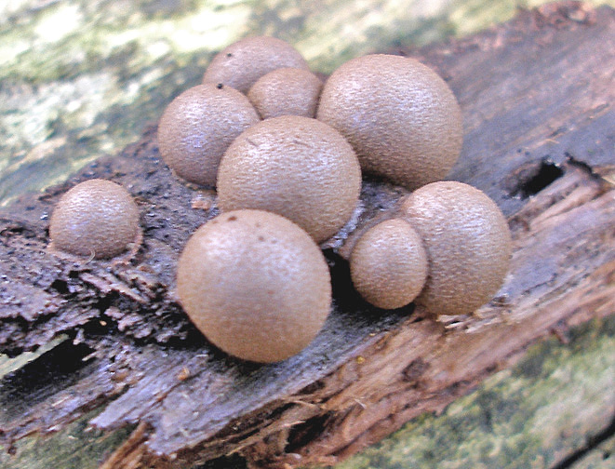

An entirely different but almost equally common species is Fuligo septica var. flava (figs.34 and 35 opposite). The septica part of the name always puts me in mind of a pile of puss on a log or leaf litter, and the flava part describes the colour which is an intense and conspicuous yellow with a hint of green. The plasmodium stage is not unlike
a dollop of scrambled egg (in my photo clearly being appreciated by the woodlouse!), followed by the drier and rather wrinkled mature stage.

